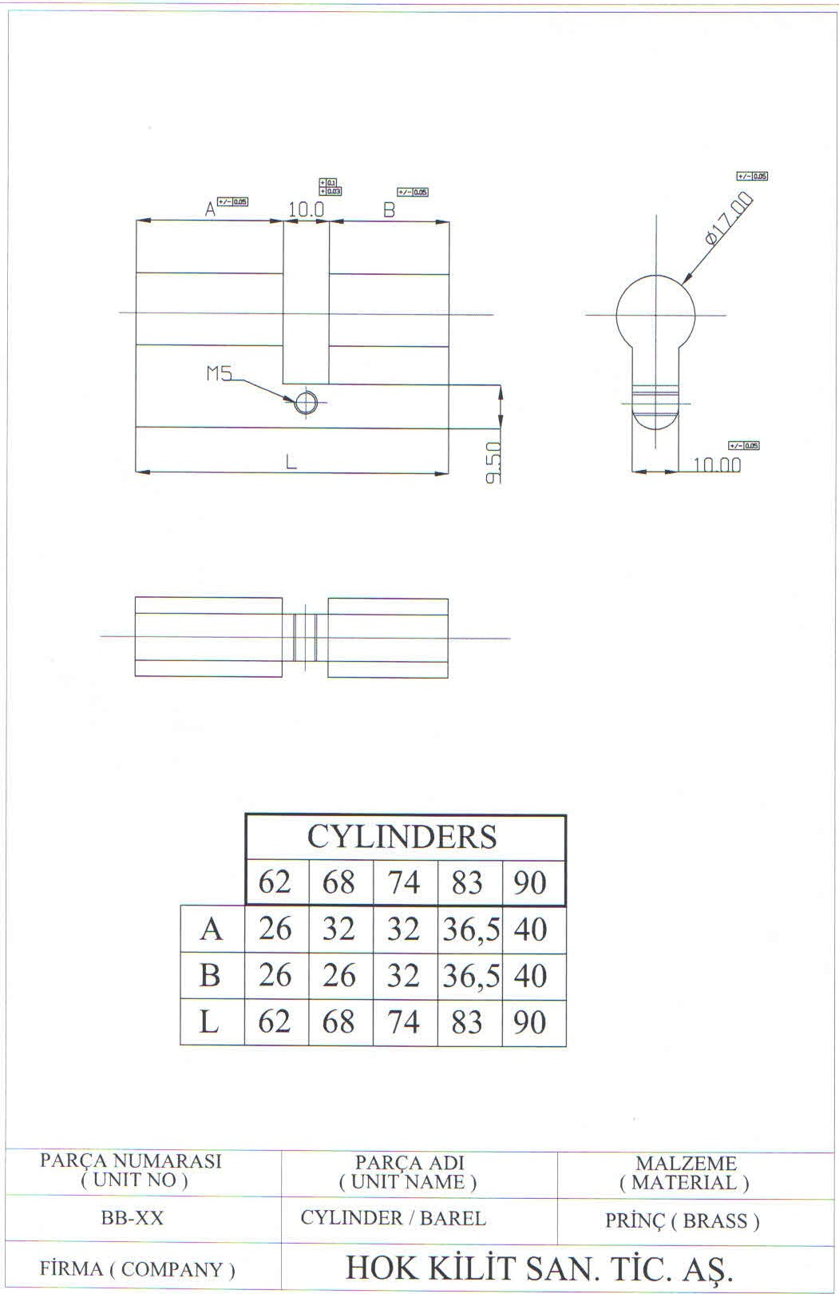
EK-A / ATTACHMENT EK-A
Ön işlem görmüş europrofil barel
Pre-processed European profile cylinder body

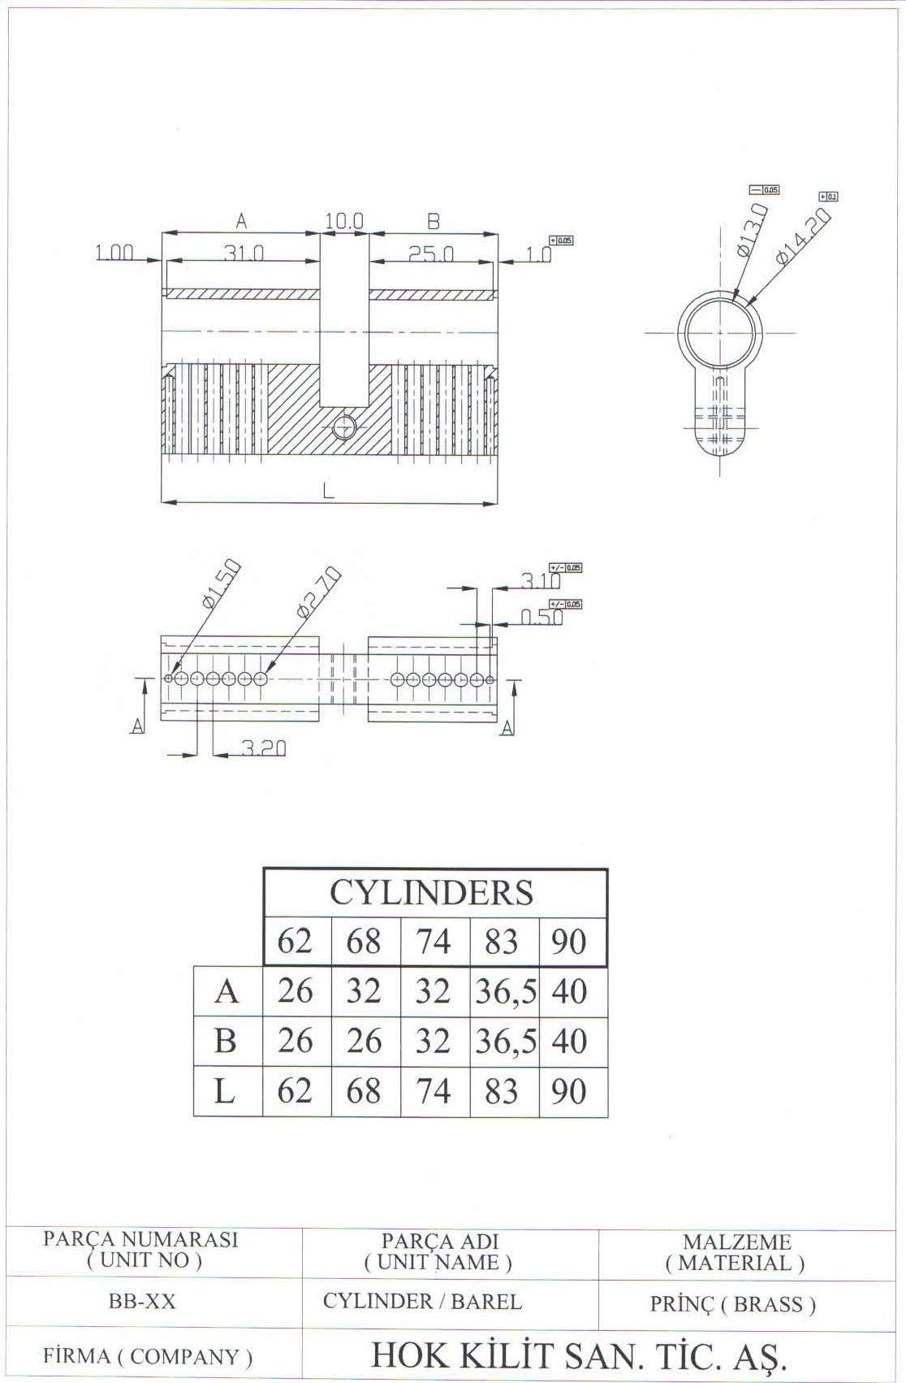
EK-B / ATTACHMENT EK-B
İstenilen (Bitmiş) euro profil barel
Desired (finished) European profile cylinder body

